**ASSIGNMENT 3**

|  |  |
| --- | --- |
| Name | Nagaarthi P |
| Roll Number | 510419106016 |
| Team ID | PNT2022TMID29529 |
| Project Name | Inventory Management System for Retailers |

**Questions:**

1. Create a Bucket in IBM object storage.

2. Upload an 5 images to ibm object storage and make it public. write html code to displaying all

the 5 images.

3. Upload a css page to the object storage and use the same page in your HTML code.

4. Design a chatbot using IBM Watson assistant for hospital. Ex: User comes with query to know

the branches for that hospital in your city. Submit the web URL of that chat bot as a assignment.

5. Create Watson assistant service with 10 steps and use 3 conditions in it. Load that script in

HTML page.

**Answers:**

1.

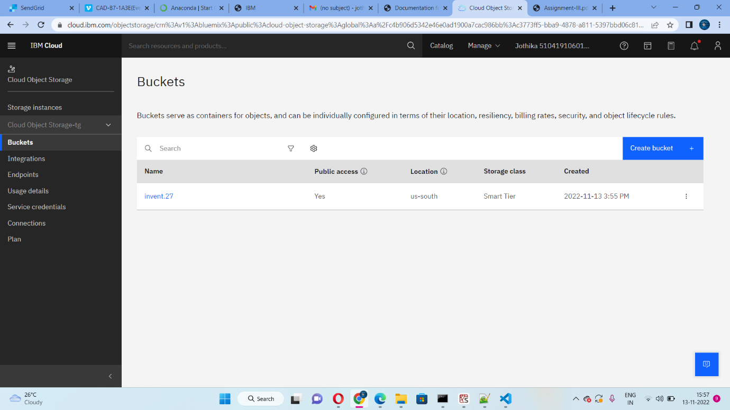

2.

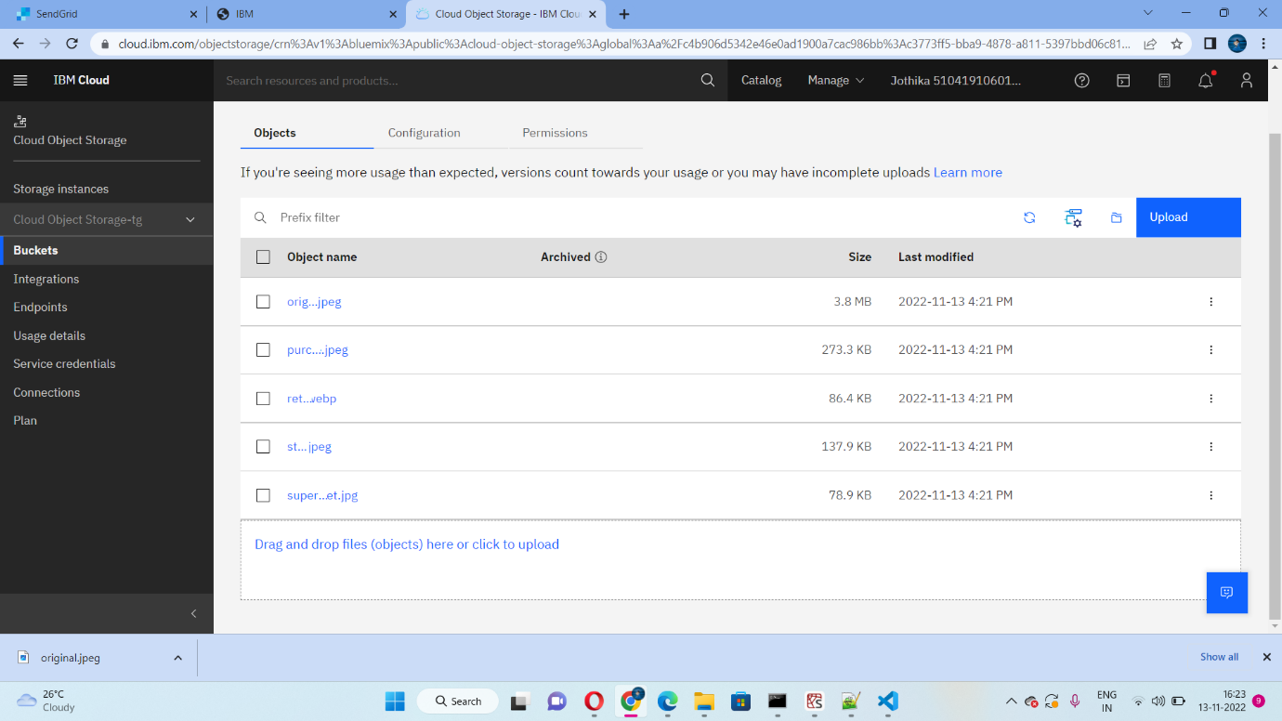

**HTML CODE:**

<!DOCTYPE html>

<html lang="en">

<head>

<meta charset="UTF-8">

<meta http-equiv="X-UA-Compatible" content="IE=edge">

<meta name="viewport" content="width=device-width, initial-scale=1.0">

<title>Inventory Management System</title>

<link rel="stylesheet" href="https://invent.27.s3.us-south.cloud-object-storage.appdomain.cloud/style.css">

</head>

<body>

<center>

<img src="https://invent.27.s3.us-south.cloud-object-storage.appdomain.cloud/original.jpeg"><h1>Inventory Management System</h1>

<img src="https://invent.27.s3.us-south.cloud-object-storage.appdomain.cloud/purchase.jpeg">

<img src="https://invent.27.s3.us-south.cloud-object-storage.appdomain.cloud/retail.webp">

<img src="https://invent.27.s3.us-south.cloud-object-storage.appdomain.cloud/store.jpeg"></center>

<center>

<img src="https://invent.27.s3.us-south.cloud-object-storage.appdomain.cloud/supermarket.jpg"></center>

</body>

</html>

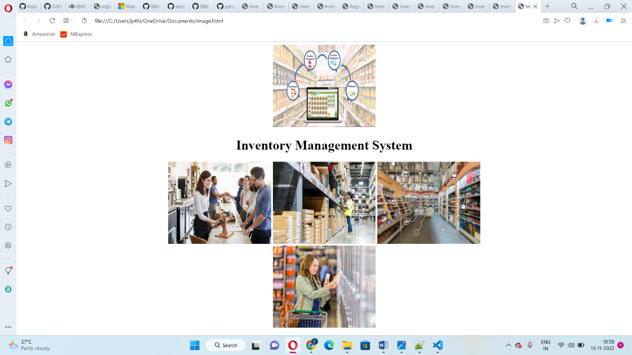

3.

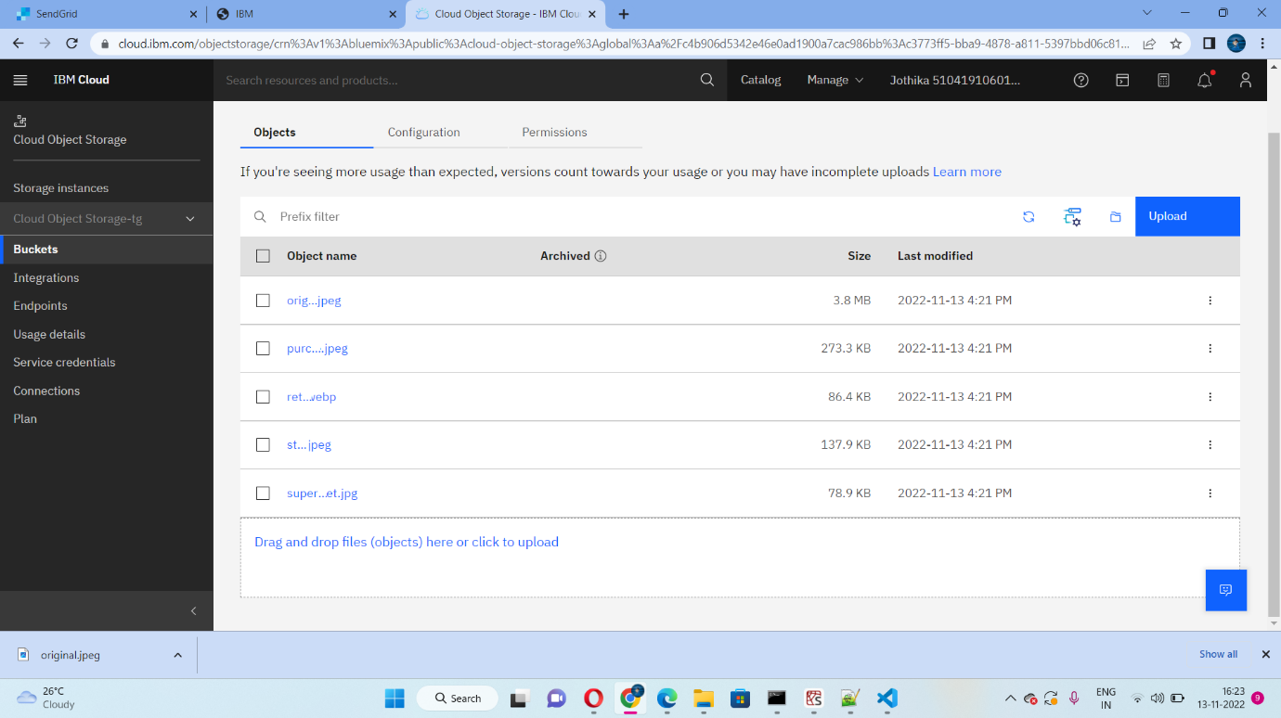

**Styles.css**

body{

background-color: rgb(125, 222, 241);

}

img{

margin:20px;

border-color: rgb(175, 244, 254);

border-style: solid;

width:300px;

height:250px;

}

4.

Chat Bot - Ginger (https://webchat.global.assistant.watson.appdomain.cloud/preview.html?backgroundImageURL=https%3A%2F% 2Fus-south.assistant.watson.cloud.ibm.com%2Fpublic%2Fimages%2Fupx-37ac1e13-ba05-43649892- 9f93f5d59696%3A%3A3e09fc9c-e564-4527-bbba-16f77749aa43&integrationID=fb6fc2359aa8-428bb2d5-932576f8933a&region=us-south&serviceInstanceID=37ac1e13-ba05-4364-98929f93f5d59696)

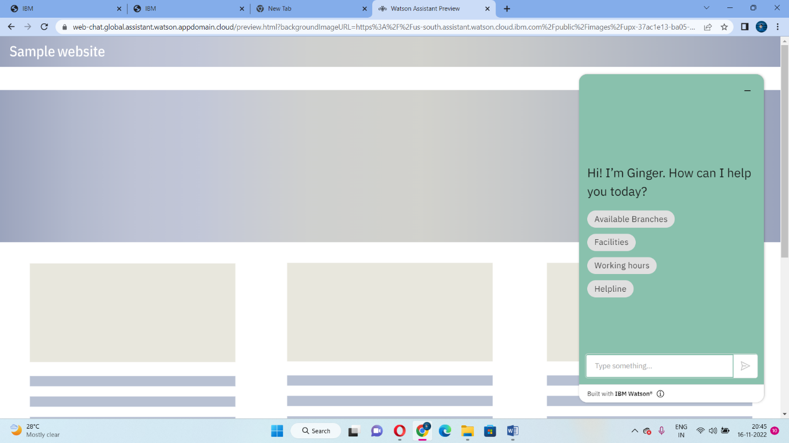

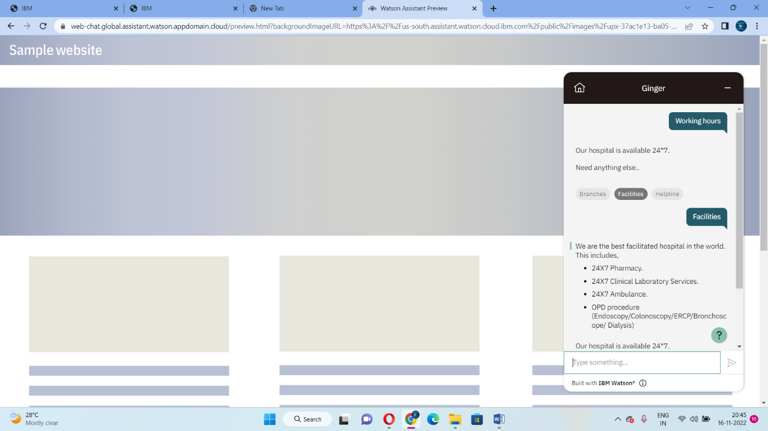

5.

<!DOCTYPE html>

<html lang="en">

<head>

<meta charset="UTF-8">

<meta http-equiv="X-UA-Compatible" content="IE=edge">

<meta name="viewport" content="width=device-width, initial-scale=1.0">

<title>Inventory Management System</title>

<link rel="stylesheet" href="https://invent.27.s3.us-south.cloud-object-storage.appdomain.cloud/style.css">

</head>

<body>

<center>

<img src="https://invent.27.s3.us-south.cloud-object-storage.appdomain.cloud/original.jpeg"><h1>Inventory Management System</h1>

<img src="https://invent.27.s3.us-south.cloud-object-storage.appdomain.cloud/purchase.jpeg">

<img src="https://invent.27.s3.us-south.cloud-object-storage.appdomain.cloud/retail.webp">

<img src="https://invent.27.s3.us-south.cloud-object-storage.appdomain.cloud/store.jpeg"></center>

<center>

<img src="https://invent.27.s3.us-south.cloud-object-storage.appdomain.cloud/supermarket.jpg"></center>

</body>

</html>

<script>

window.watsonAssistantChatOptions = {

integrationID: "cdfd03c8-a733-4b80-91cb-f2f1e34bda17", // The ID of this integration.

region: "au-syd", // The region your integration is hosted in.

serviceInstanceID: "ab9b9683-d04e-4af9-92ed-50ce38ac0c8c", // The ID of your service instance.

onLoad: function(instance) { instance.render(); }

};

setTimeout(function(){

const t=document.createElement('script');

t.src="https://web-chat.global.assistant.watson.appdomain.cloud/versions/" +

(window.watsonAssistantChatOptions.clientVersion || 'latest') + "/WatsonAssistantChatEntry.js";

document.head.appendChild(t);

});

</script>

</body>

</html>

